Documentation Page

Project 1

Tommy Schmelzer

Map

* Brewery
* Workhouse
* Points: colors

Deathday Graph

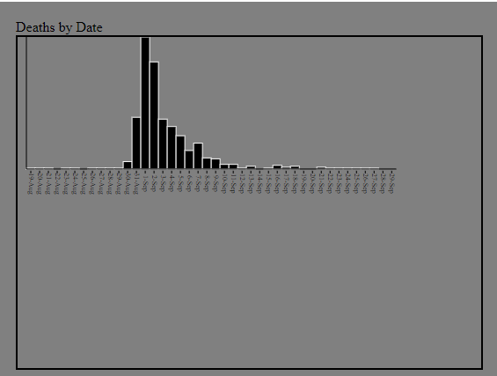

The graph above shows the total amount of deaths on each individual day for the Cholera outbreak in 1854. I drew the axes using the line function and the bars using the rect function. I outlined the bars to help them stand out against the dark gray background. The x axis contains the day whereas the y axis represents the number of deaths. Future work on this visualization would be to add detail to the y axis and enlarge the graph to make the single digit death days more visible than its present state. Filters can also be added to filter the amount of deaths on a certain day or range of days.

Gender Pie Chart

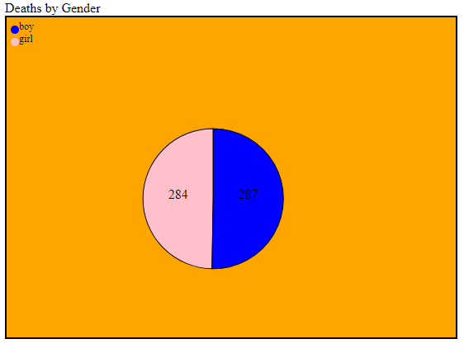

Age Graph

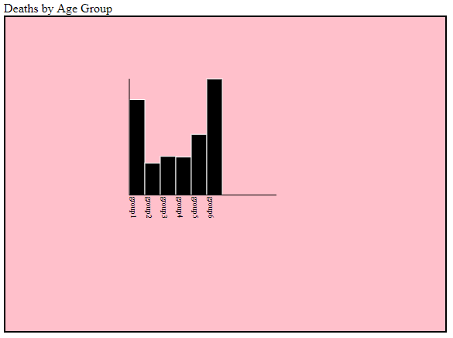

The visualization above is a representation of the total amount of deaths and their classified age group. As we can see, children and elderly were heavily impacted by the Cholera outbreak. The pink background allows the black bars and labels to contrast. Future work with this visualization would be include details along the y axis and label the total amount of deaths at the top of each bar on the graph.